**Team members:**

1. Bhavya Sri Sirasanagandla

Contribution: 50%

1. Manideep Nadimpelli

Contribution: 50%

**Objective:**

The main objective of this application is to perform customer CRUD operations using MEAN Stack.

**Pre requisites:**

1.WebStorm IDE

2.Node

3.Expressjs

4.Angular

5.MongoDB.

**MongoDB Setup:**

1.Created mongo db atlas account in [https://cloud.mongodb.com](https://cloud.mongodb.com/).

2. Followed below steps to create database, collections.

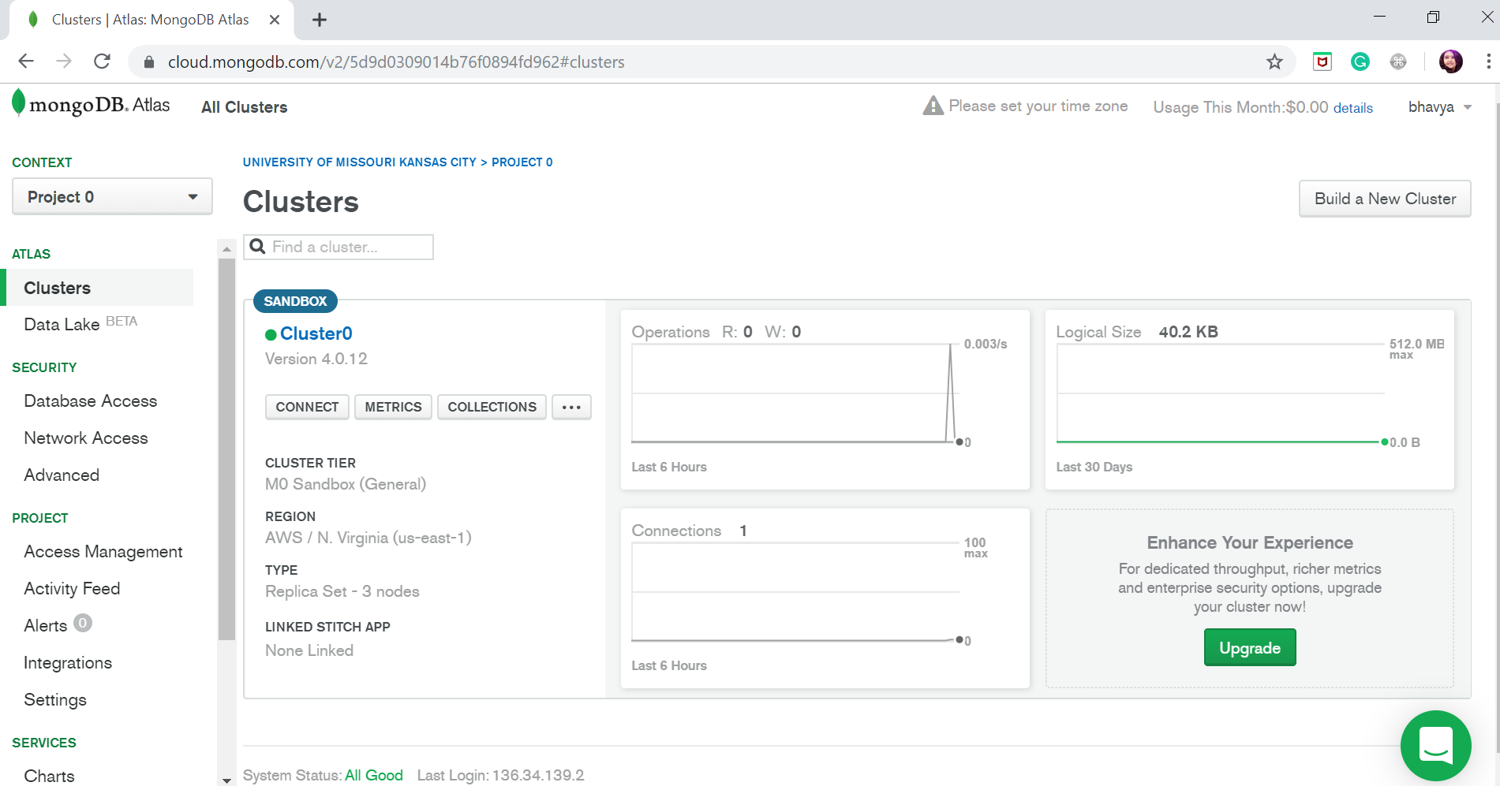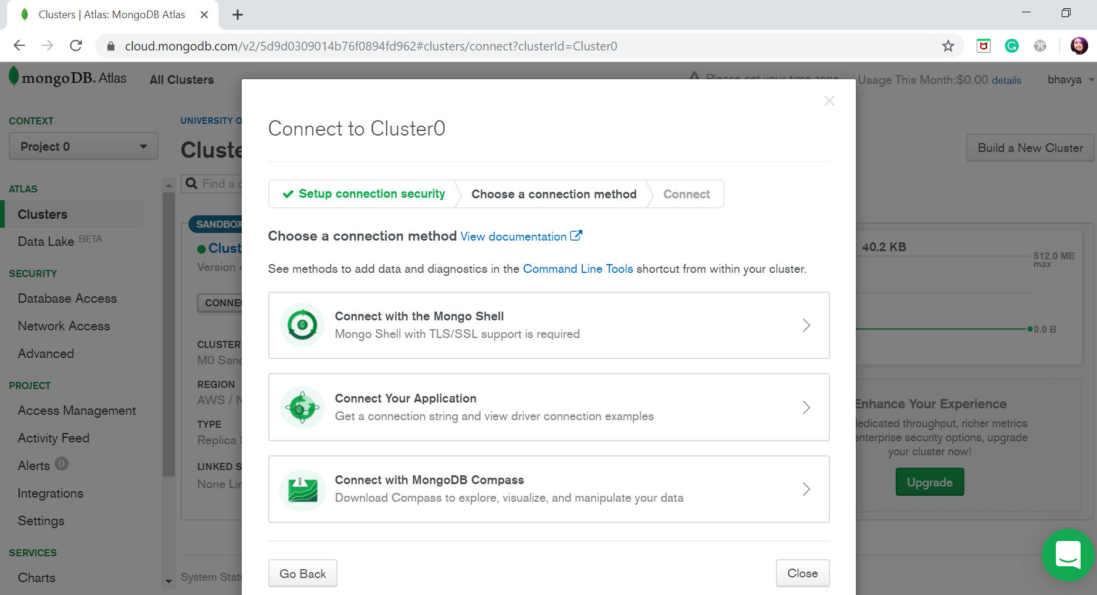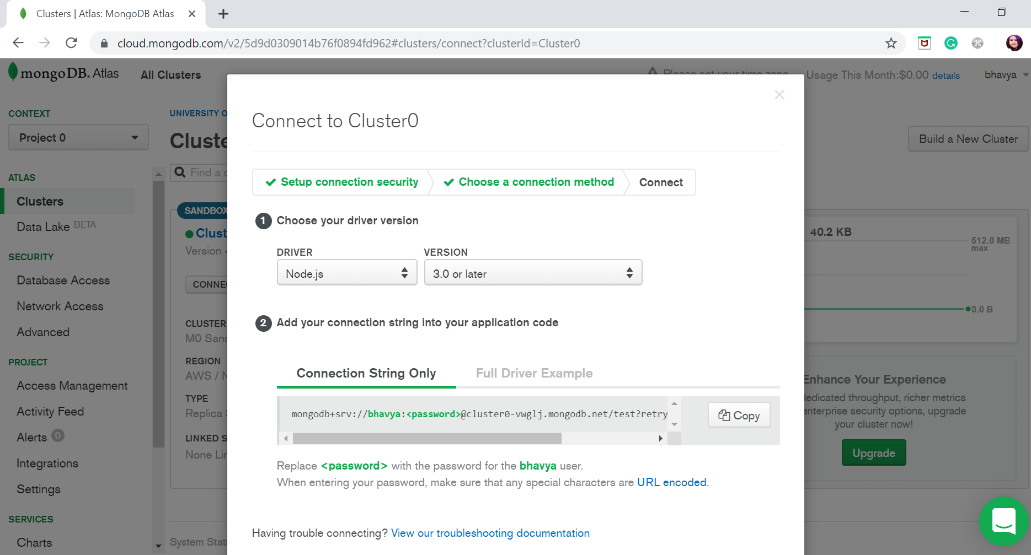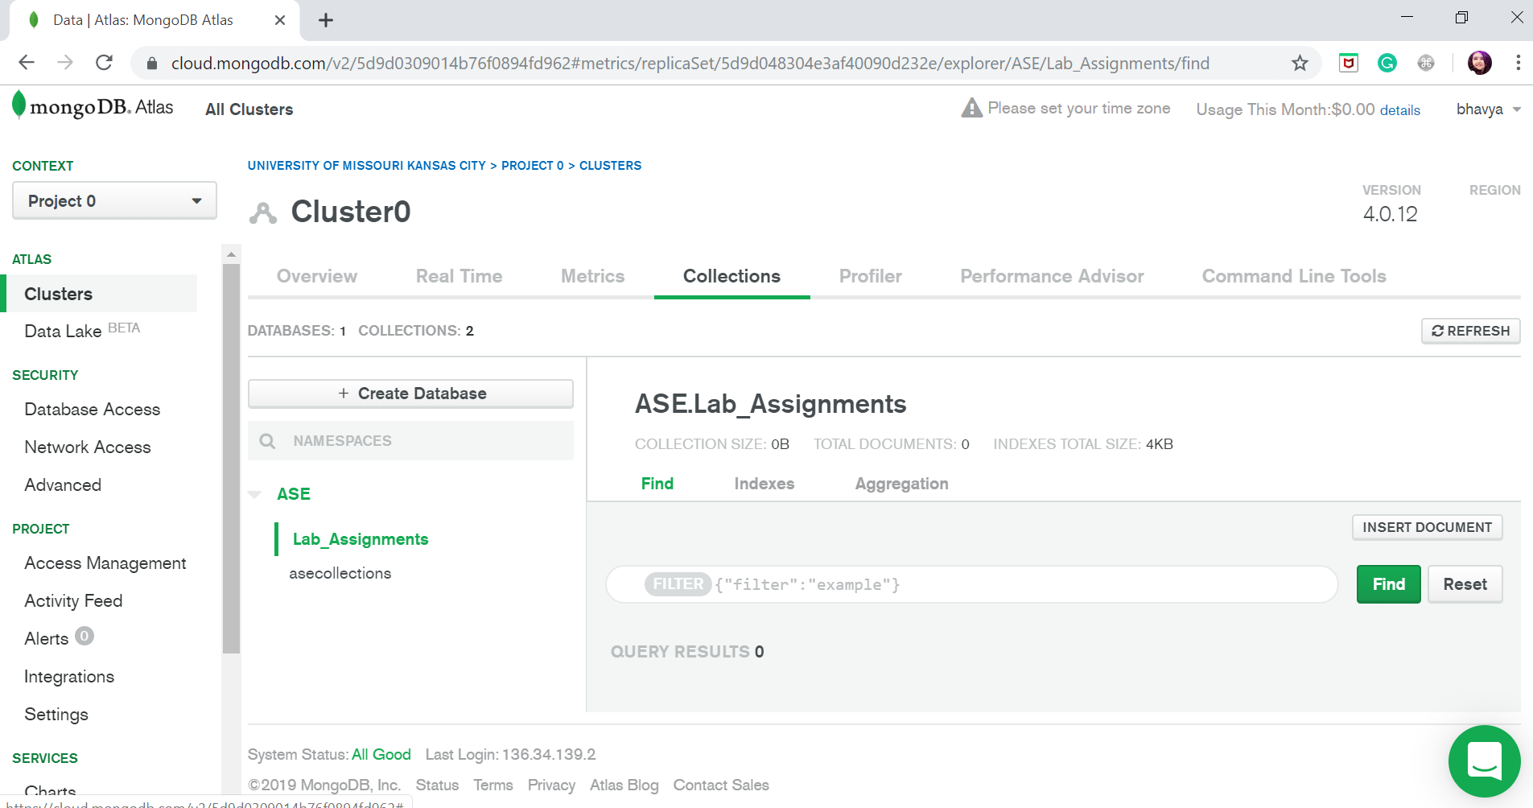

**Implementation:**

1. Created customer details, create customer, customers components.
2. Configured routing modules in app.routing.modules.ts.
3. UI code was written in for customer details, create customer, customers components.

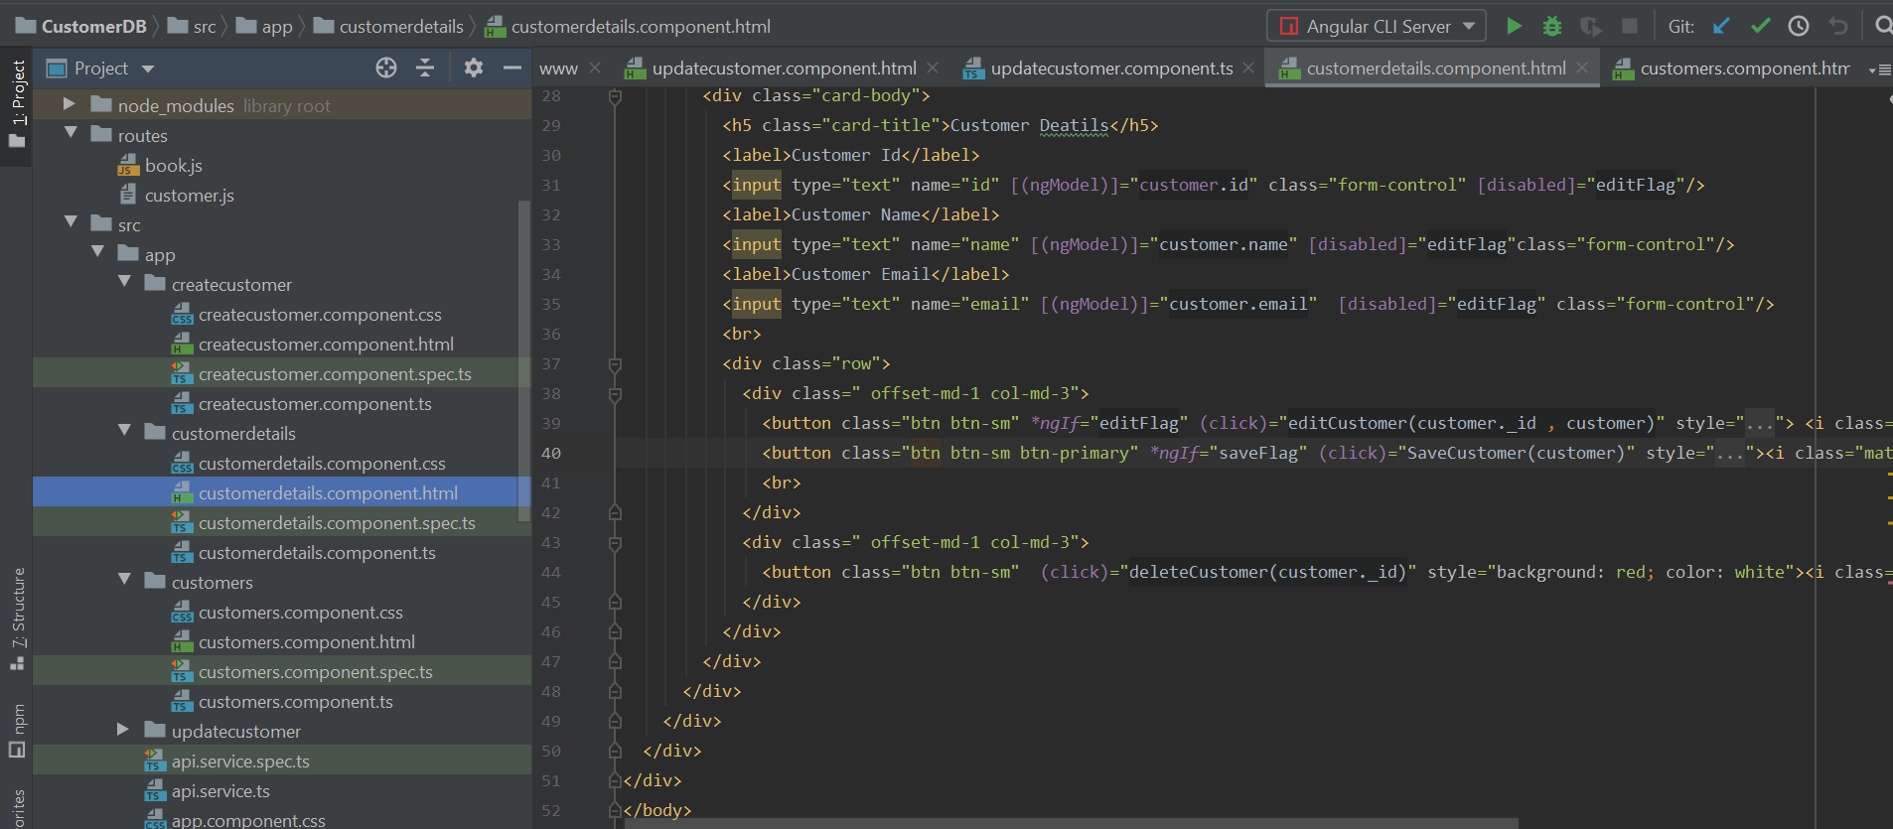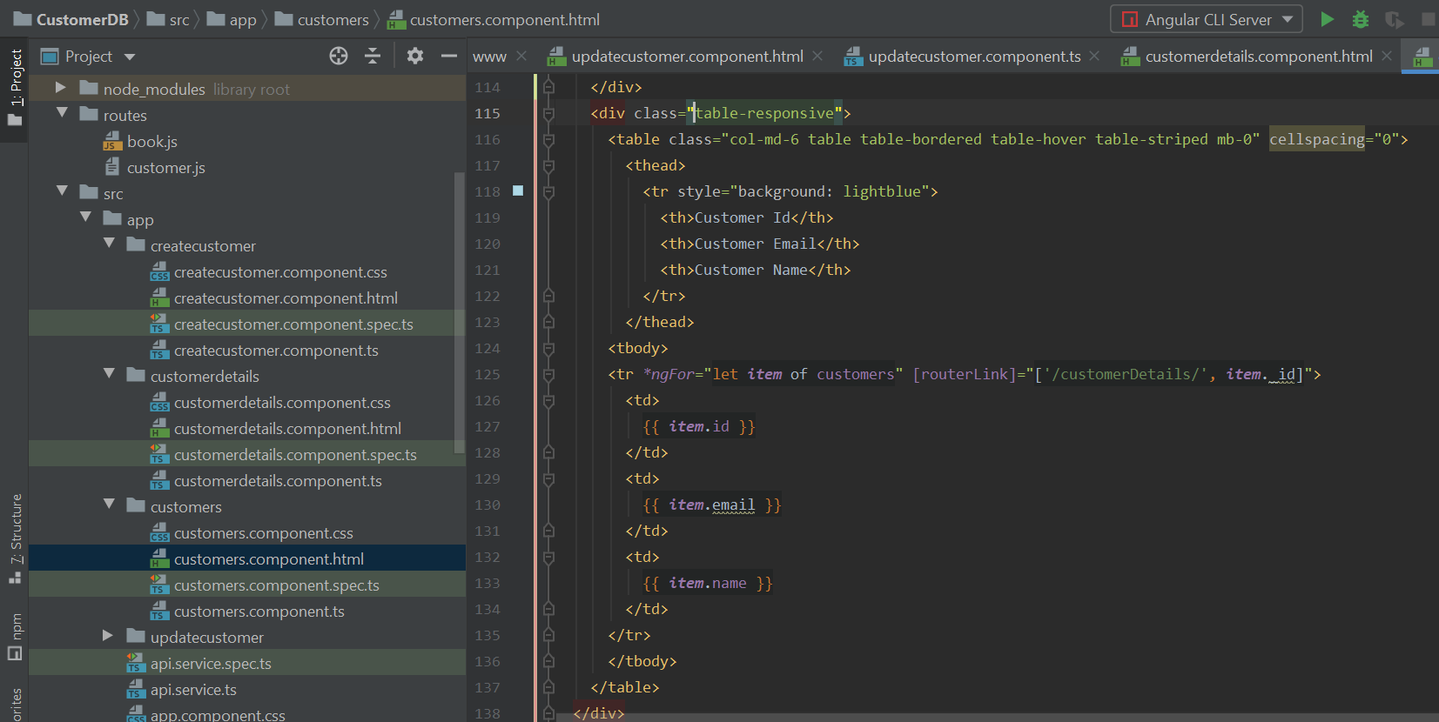

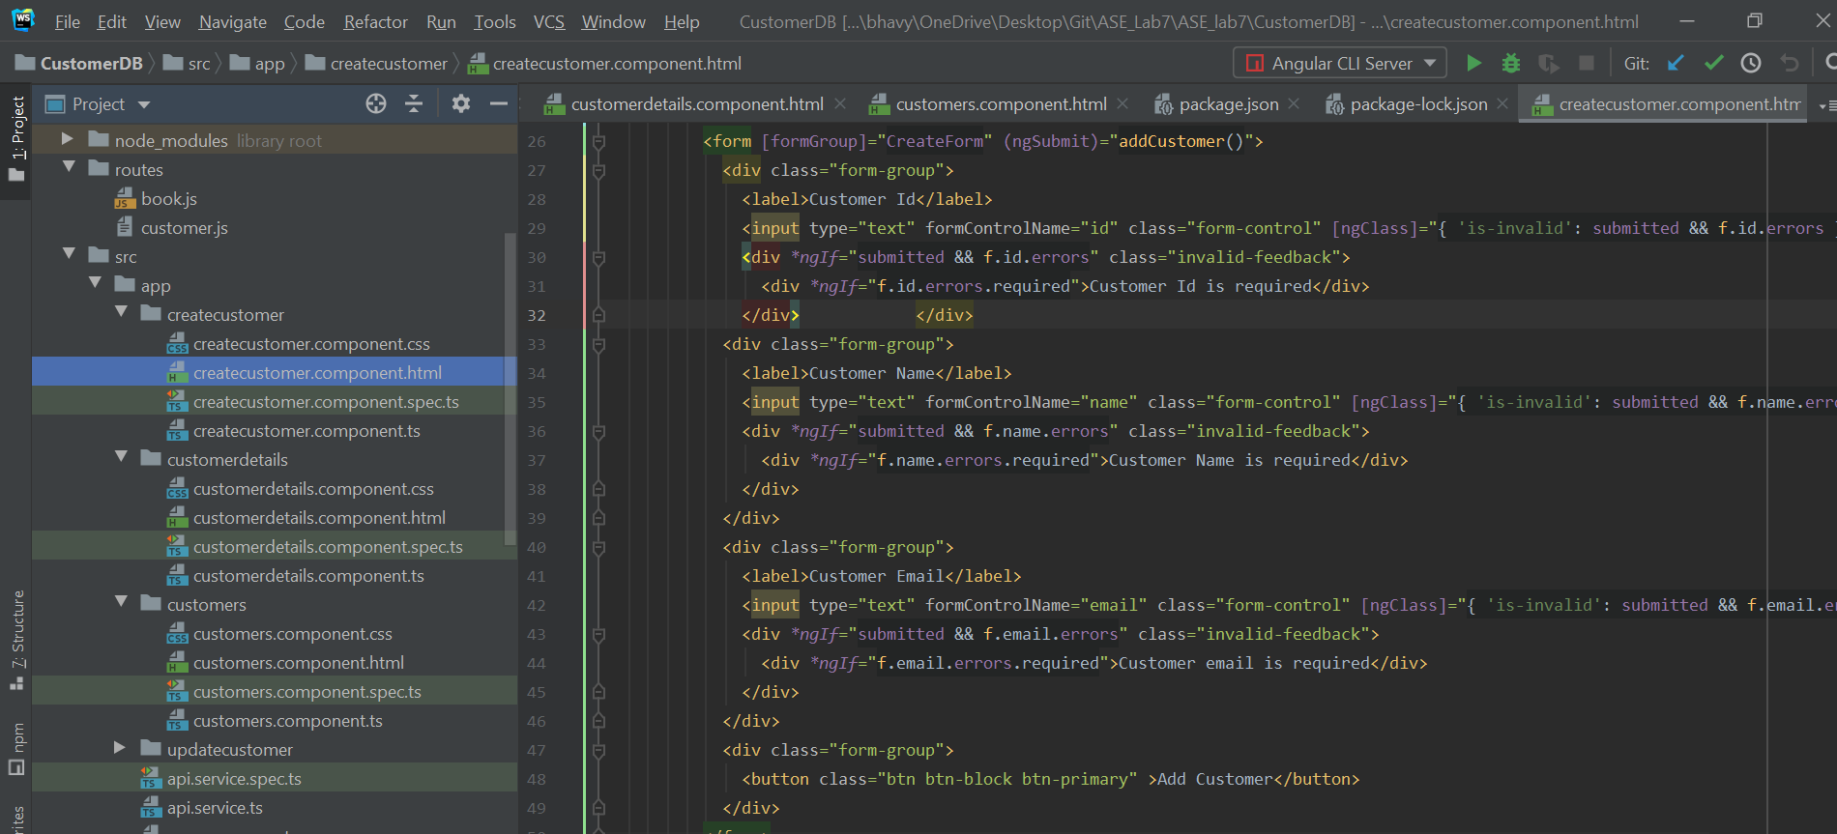

1. Created api service written CRUD functions.

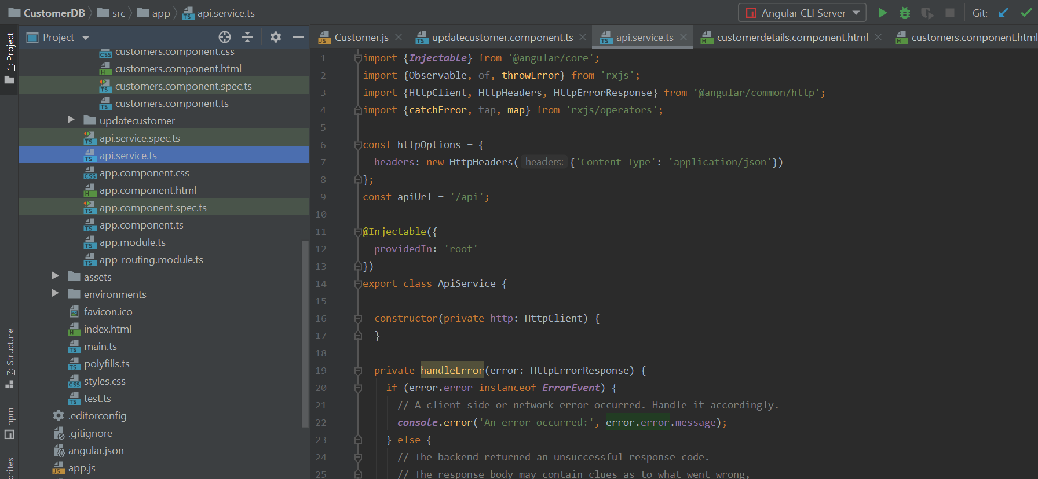

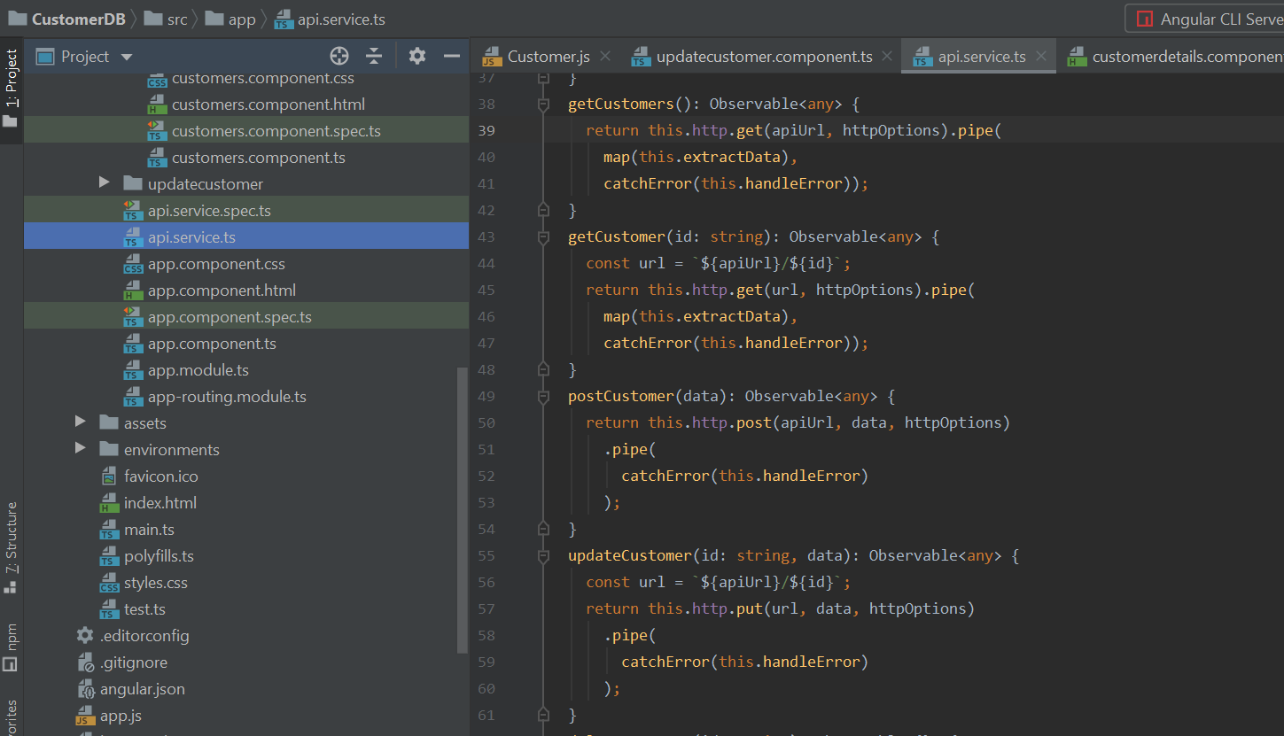

1. Created CRUD functions in ts files.

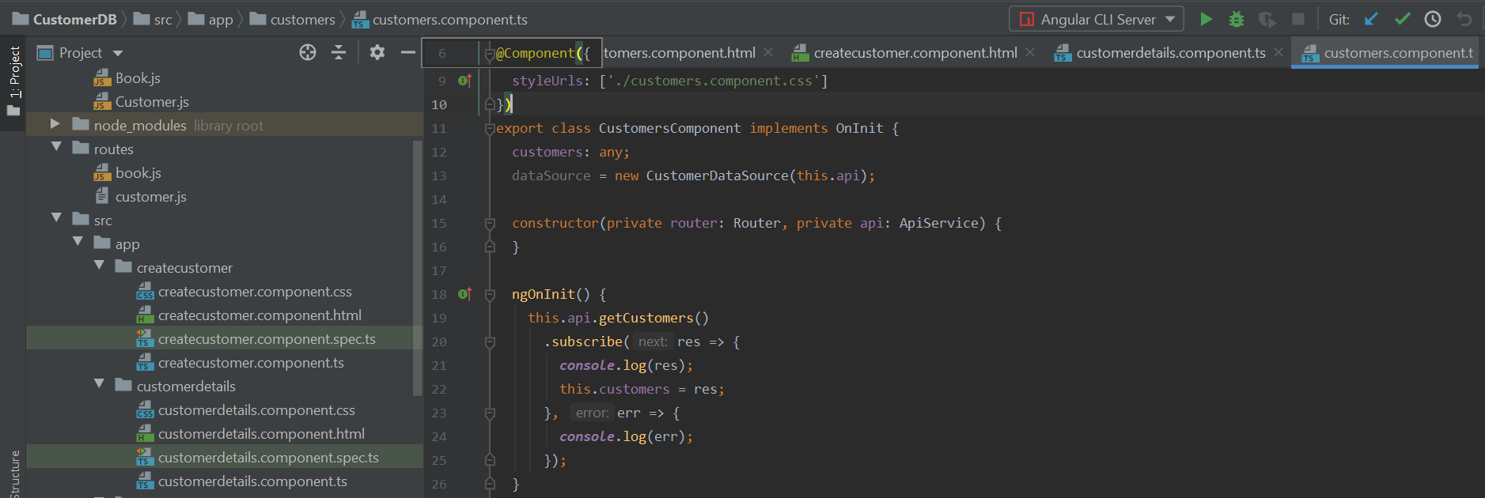

. 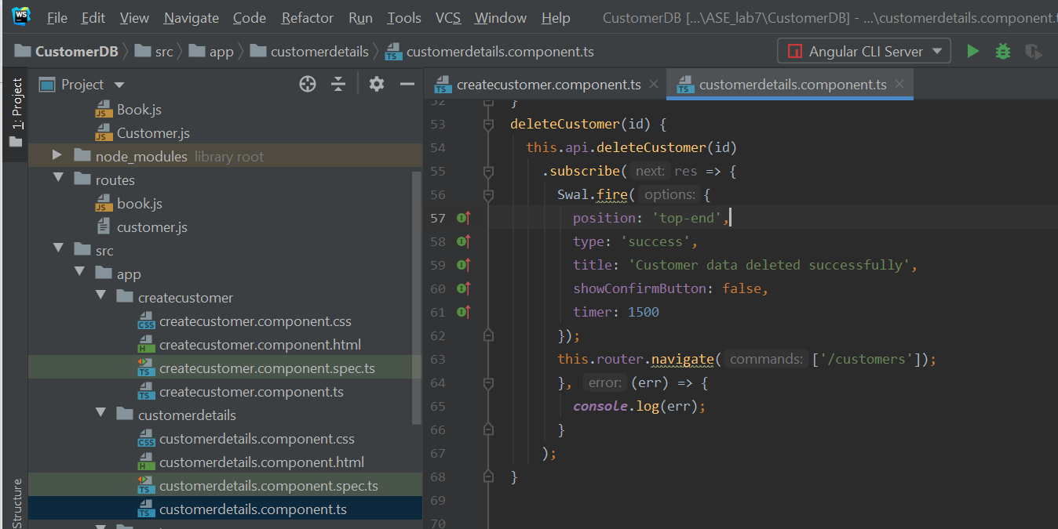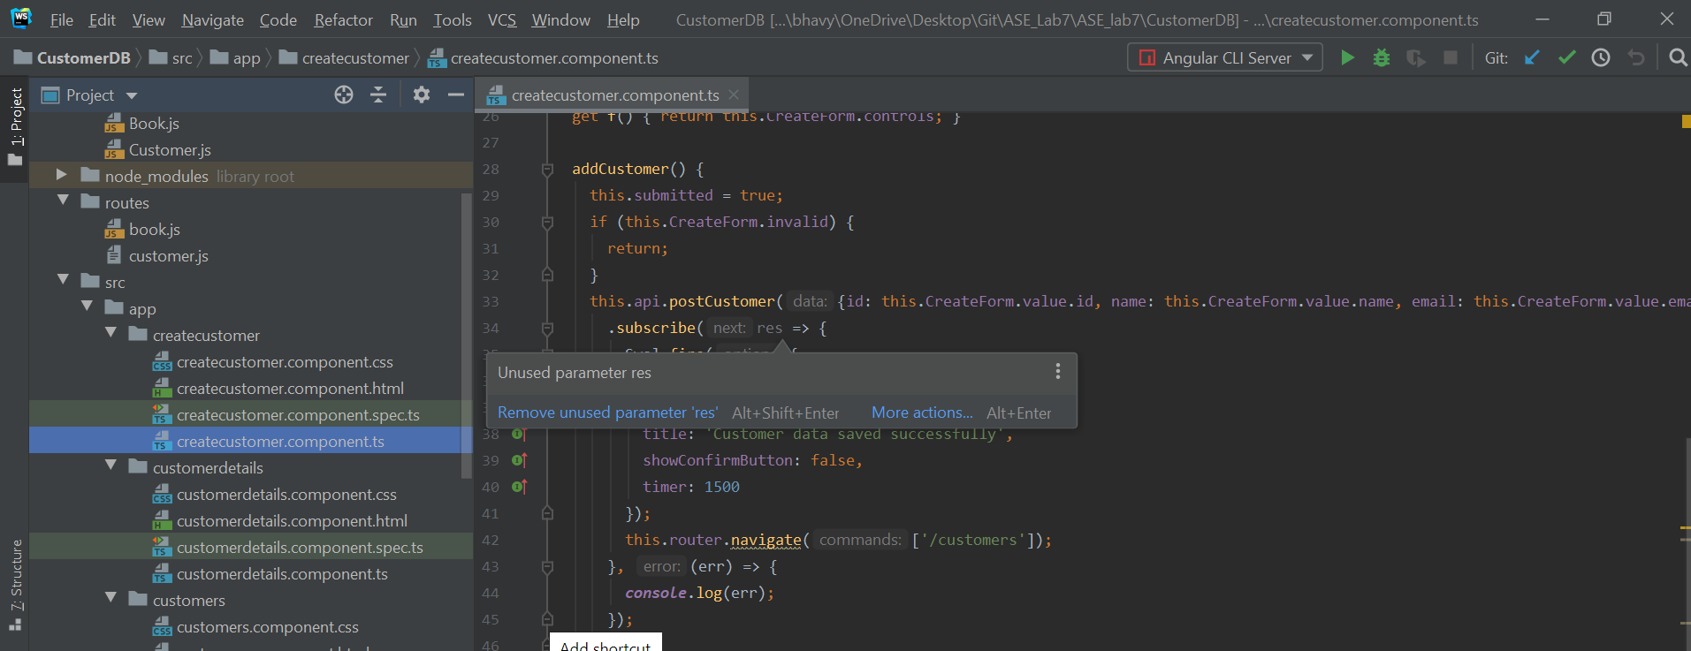

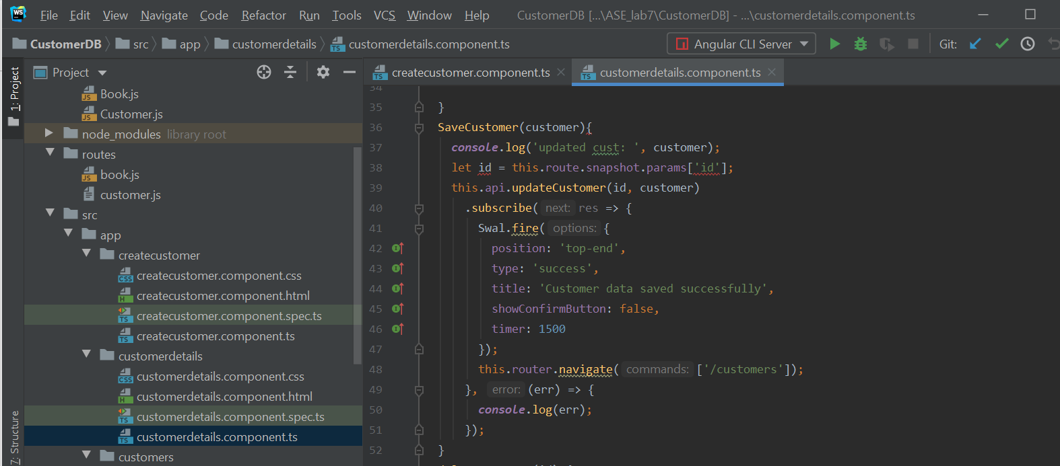

1. Created www file in bin folder, added code to connect to port 3000.

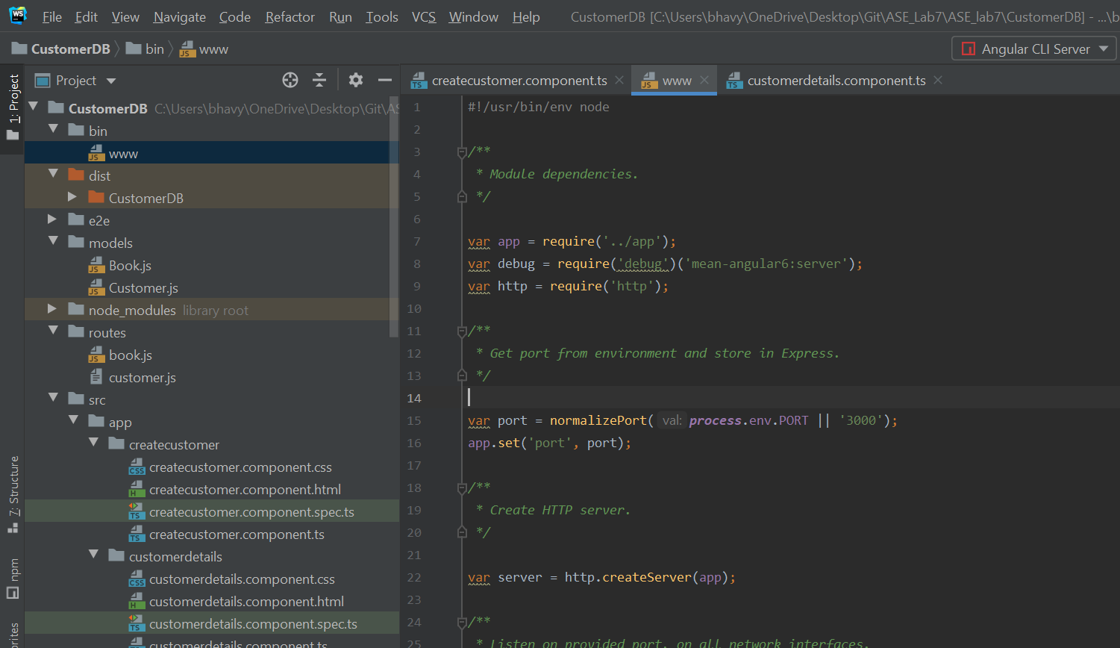

1. Connected MongoDB database with our application. For that we have app.js file and added path to connect to mongodb.

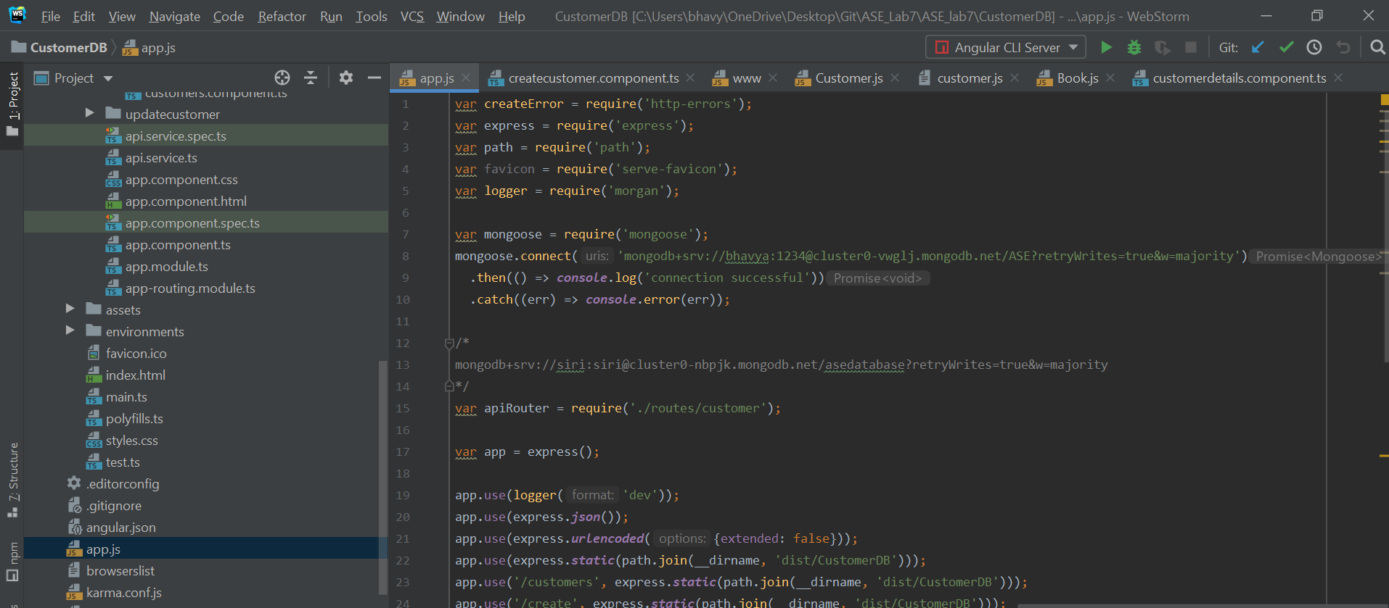

1. Created Routes in customer.js file.

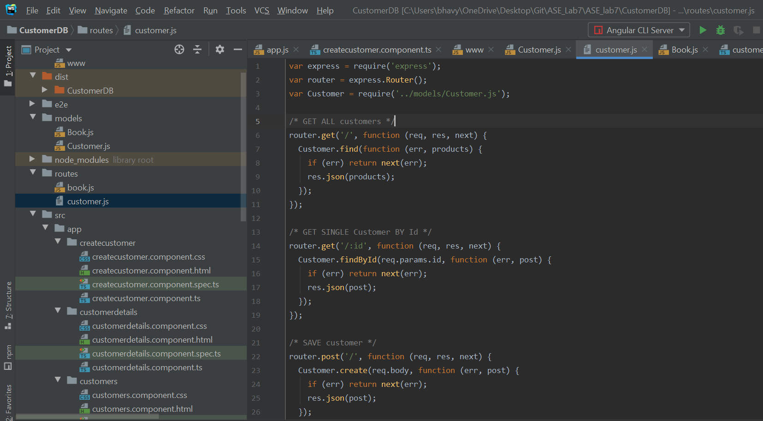

**Sample Output:**

1. By default, the total number of customers are displayed.

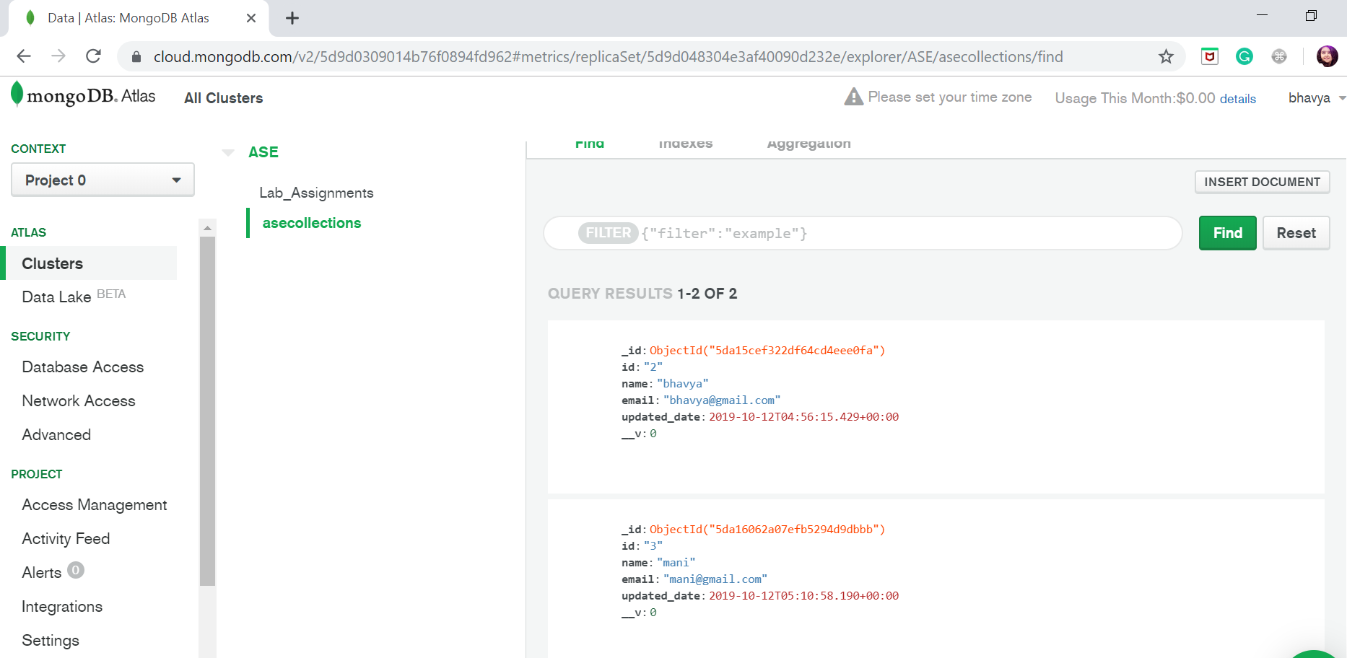

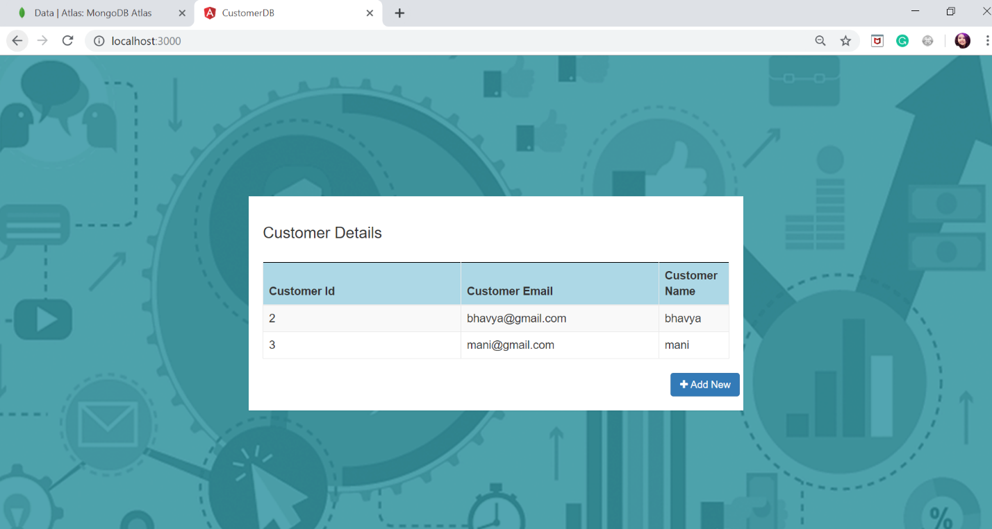

1. Added form validations for add customer form.

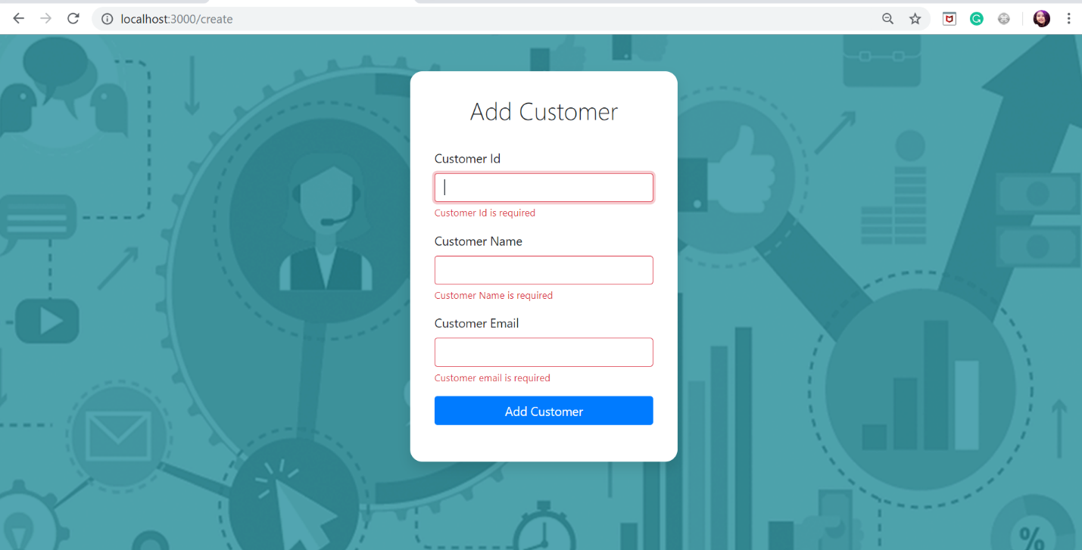

1. To add a customer.

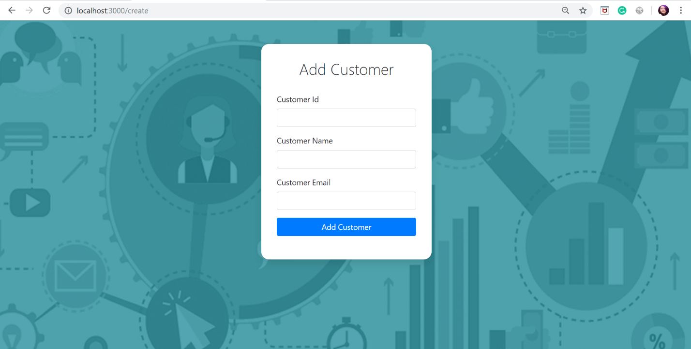

Added success messages for add customer operation

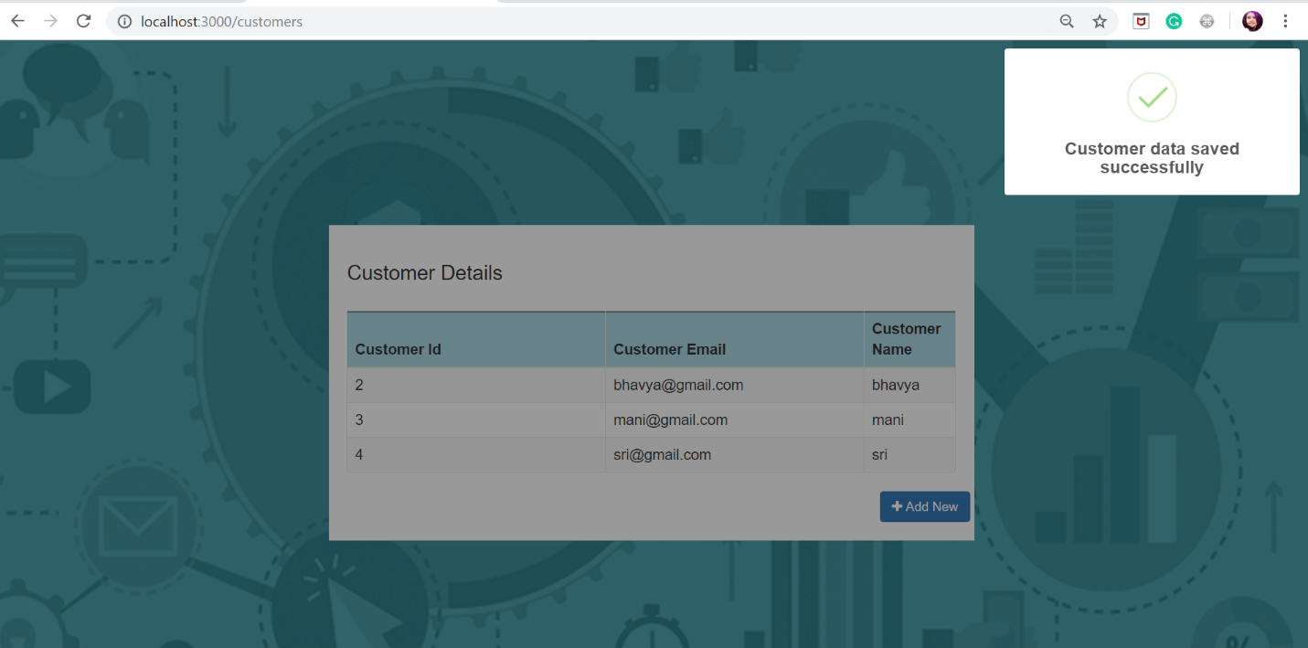

Data is stored in mongodb database.

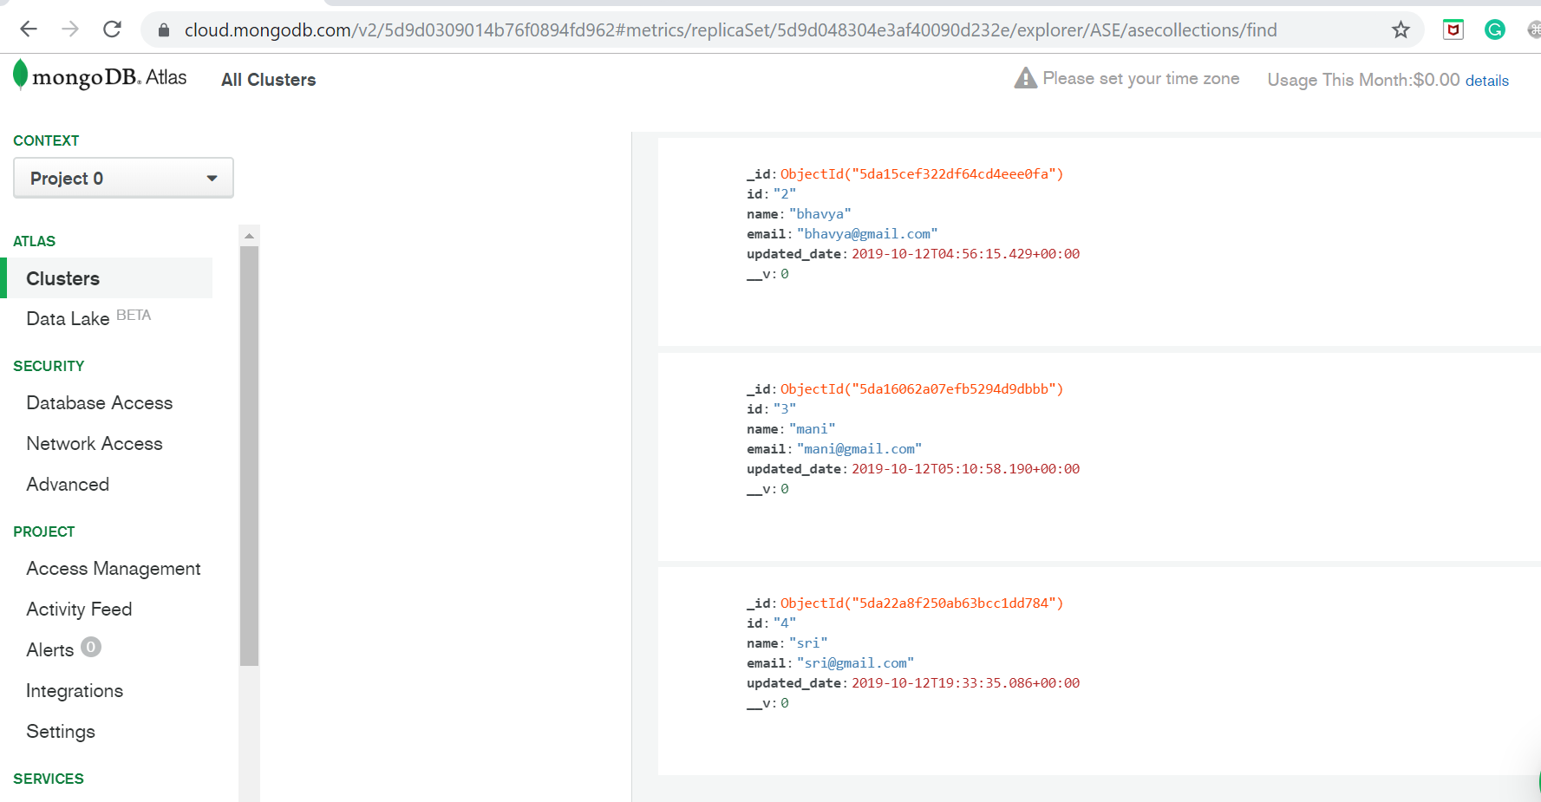

1. To Update or delete customer data user has to click on table row which will navigate to the customer details page.



Now on click of edit all the fields will be enabled user can update the data.

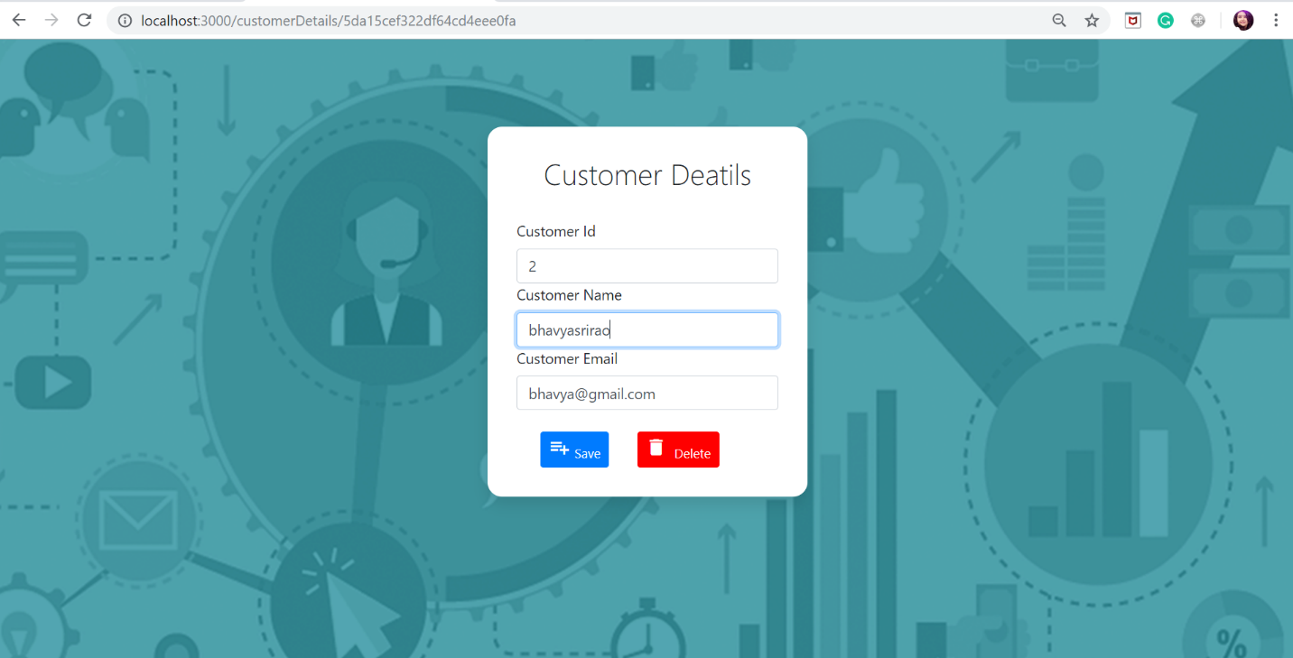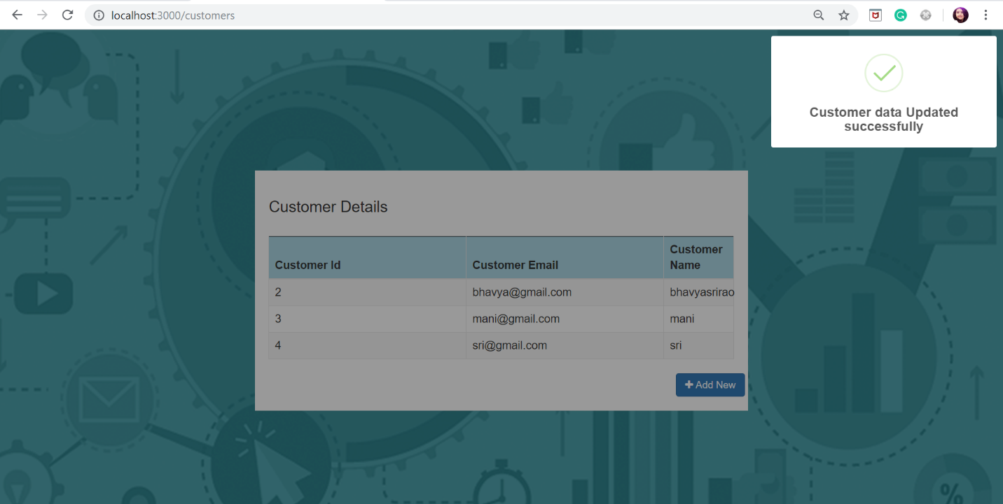

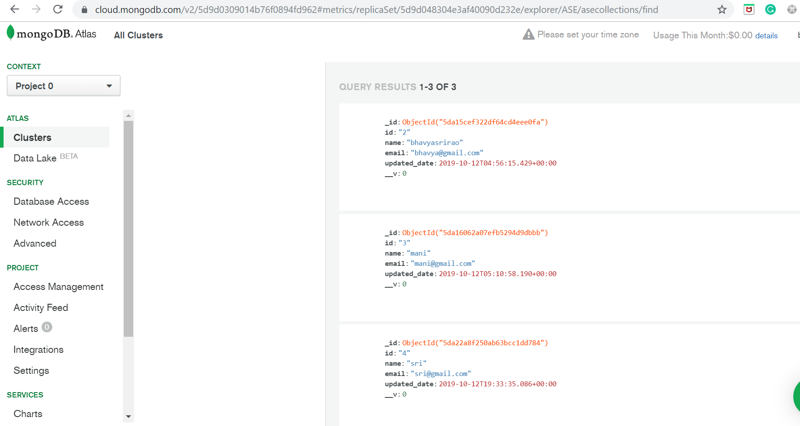

1. For Deleting a customer user has to navigate to the customer details page by clicking on the customer data row.



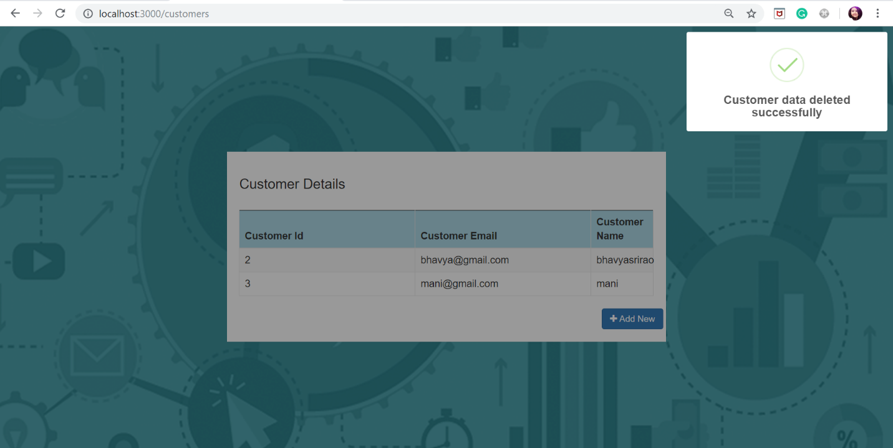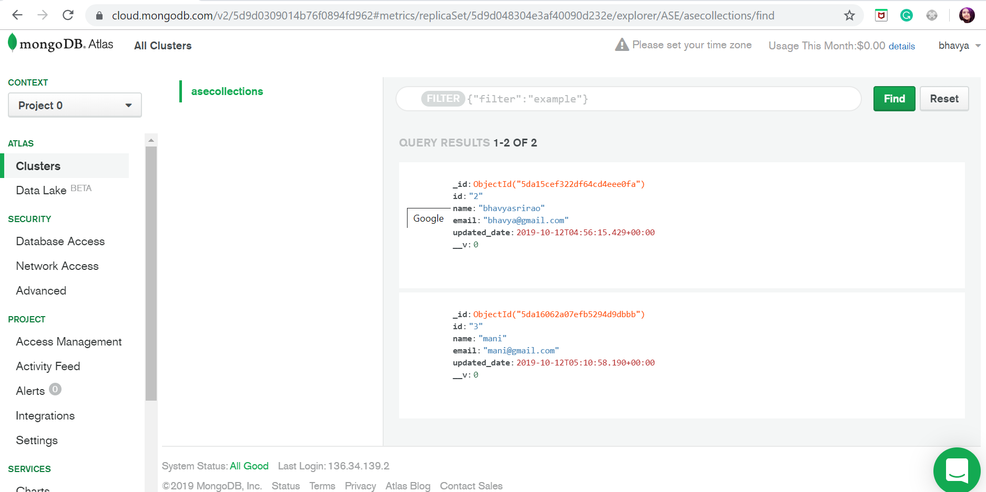

**Conclusion:**

* We analyzed the given source code for this assignment. Created MongoDB account and performed CURD operations on customer data. We got an idea on how a MEAN stack application flow works.